Appendix 4: SWIFT Qualitative Interview Guide: Clinic staff




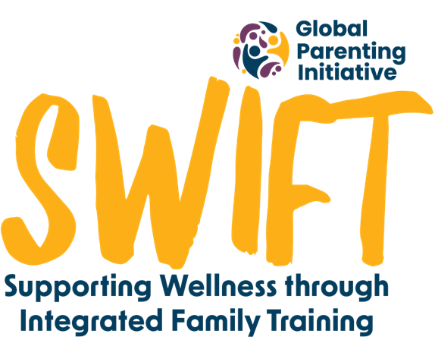


Briefing:
Thank the interviewee for making the time to attend the interview.
Thank you for participating in this interview. It will take about 30 minutes. I will need to record this conversation, with your permission, so that we can listen to your contributions at a later stage. However, all your responses will remain confidential and will only be viewed by the research team.
There are no right or wrong answers. We are simply interested in learning about your experiences of how we implemented the ParentText WhatsApp programme, so that we can understand what did and didn’t work.
Because we want your name and identity to remain private, and this discussion is being recorded, we will not use your name in any of the documents we write up after this discussion.
Please remember that you are able to leave this interview at any time if you would like to, or you can choose not to answer any questions that you don’t want to respond to, for any reason. If you decide at a later stage that you would like your contribution to be removed from the study, you can contact the research team by email up until the [date to be determined]. After this point we would have started to share our findings. Before you sign the consent form, do you have any questions?
- At this point, ask them to sign the consent form
Thanks again for participating in this interview. Please let me know if any of my questions are confusing.

[please ensure you probe on all of the below questions]

- Recruitment and encouragement.

I’d like to begin by asking you about your experience of the way patients heard about the ParentText programme.

- What was your experience of the posters that were up in the clinic to recruit caregivers?
- Probe: What did you like about the posters? How do you think they could be improved?
- Probe: What did you think of the number of posters that were up? Where else do you think we should have put posters in clinics?
- Probe: What did patients say about the posters? Did they mention seeing the posters or say anything else about the posters?

- What was your experience of encouraging patients to sign up to ParentText?
- Probe: Which parts felt easy? What did you find difficult?
- Probe: How much time did it take to encourage patients? How did you find fitting it into your patient load and other work responsibilities?
- Probe: How did patients respond to the encouragement? Did they find it clear enough? Did it give them enough information? If not, how should we amend the script?
- Probe: When you mentioned the programme, did any patients make the connection between your encouragement and seeing a poster about ParentText?
- Probe: What do you think about the overall need for the encouragement component? Did you find it useful/necessary?

- What was your experience during the ‘non-encouragement week?’
- Probe: How did you find not being able to tell patients about the program in the non-encouragement week?
- No judgement, did you tell anyone about the program in the non-encouragement week?
- Probe: In the non-encouragement weeks, did you have any patients asking you about the programme? How did you handle that?

- Did you hear anyone talking about the programme outside of the clinic?

B. The ParentText programme.
Now I’d like to ask you about the ParentText programme itself.
- Could you tell me what you think your overall sense of the patients’ overall interest in ParentText was? What did they say or do that made you think this?
- When seeing your patients again, did you receive any feedback from them about the programme?
  - If yes: What did they say? Did they like the program? What didn’t they like about it?
  - Did any of them speak specifically to you about the ‘keeping your child safe’ module? Was there any additional support you needed to give them?
- Did you go through the programme yourself as a parent/caregiver? If yes, what did you think of it?
- Probe: What do you like about it?
- Probe: What do you think could be improved? Do you feel like it was missing anything e.g. in terms of content or referrals?
- Probe: Did you do 1 module or 2? What did you think of the second module?
- Did you tell anyone about the program outside of your work encouragement “responsibilities”?
- Probe: May I ask who it was, not their name, but their relationship to you? Do you know if they joined? Did they share anything with you about the program?
5. Did you speak to any colleagues about the program? If so, what were the types of things people were commenting on?
C. Intervention sustainability.
I’d like to ask your thoughts about us rolling out this intervention on a long-term basis.
- Firstly, do you think we should? Do you think there is a need for this programme?
- Probe: What makes you say that? What is your overall sense of interest in ParentText?
- What do you think about the fact that the intervention is promoted in clinics?
- Probe: Should nurses be the ones to encourage? If not, who?
- Probe: Where else do you think this program should be advertised?
- Probe: Are there better ways to get parents/caregivers attention without increasing the cost too much?
- We placed this study in a clinic which meant that nurses were able to do the encouragement; in rolling this out do you think the encouragement component of the study is important to parents signing up to the programme?
- Probe: Why do you think so?
- Do you think it’s important to encourage patients to sign up to the programme or do you think the posters are enough to get their attention?
- Probe: How else do you think we could get their attention in a clinic setting?
- Probe: How could we get their attention in other settings? E.g. schools, taxi ranks
- What is your impression of nurses being the encouragers for this intervention? Do you think it is a) feasible and b) realistic to continue to ask nurses to promote the programme during their routine consultations with patients? Why/why not for a) and b)?
D. Potential for digital interventions.
The next few questions are about your thoughts around the potential for digital/online/virtual interventions.
- Based on your experience with the ParentText programme – What do you think about a purely digital intervention like this? Do you think it can help people in your community? Why/Why not?
2. Which services provided in-person do you think a digital platform like this could be useful for?
3. In your work with patients, are there non-medical issues which come up in your appointments with them that you think can be supported digitally like this program is doing for parenting?

Debriefing
Thank you for your contributions so far. We will be finishing the interview soon; I just have two more questions.
- Is there anything else you want us to know about that we didn’t ask? Anything else to share?
- Do you have any questions for me?
Was there anything that made you feel a bit unsettled while doing this interview that you would like us to refer you to support for? (if they become visibly unsettled then speak directly to a referral for that).

We’ve come to the end of our interview. Thanks again for taking the time to come speak with us today. I know you’re busy. Your responses have been very helpful!

